Name: Shreyash Kamat Div: D15C Roll no: 22

Static Hosting:

# 1) On local server (XAMPP)

**Step 1:** Install XAMPP from <https://www.apachefriends.org/>

1. Select your OS. It will automatically start downloading.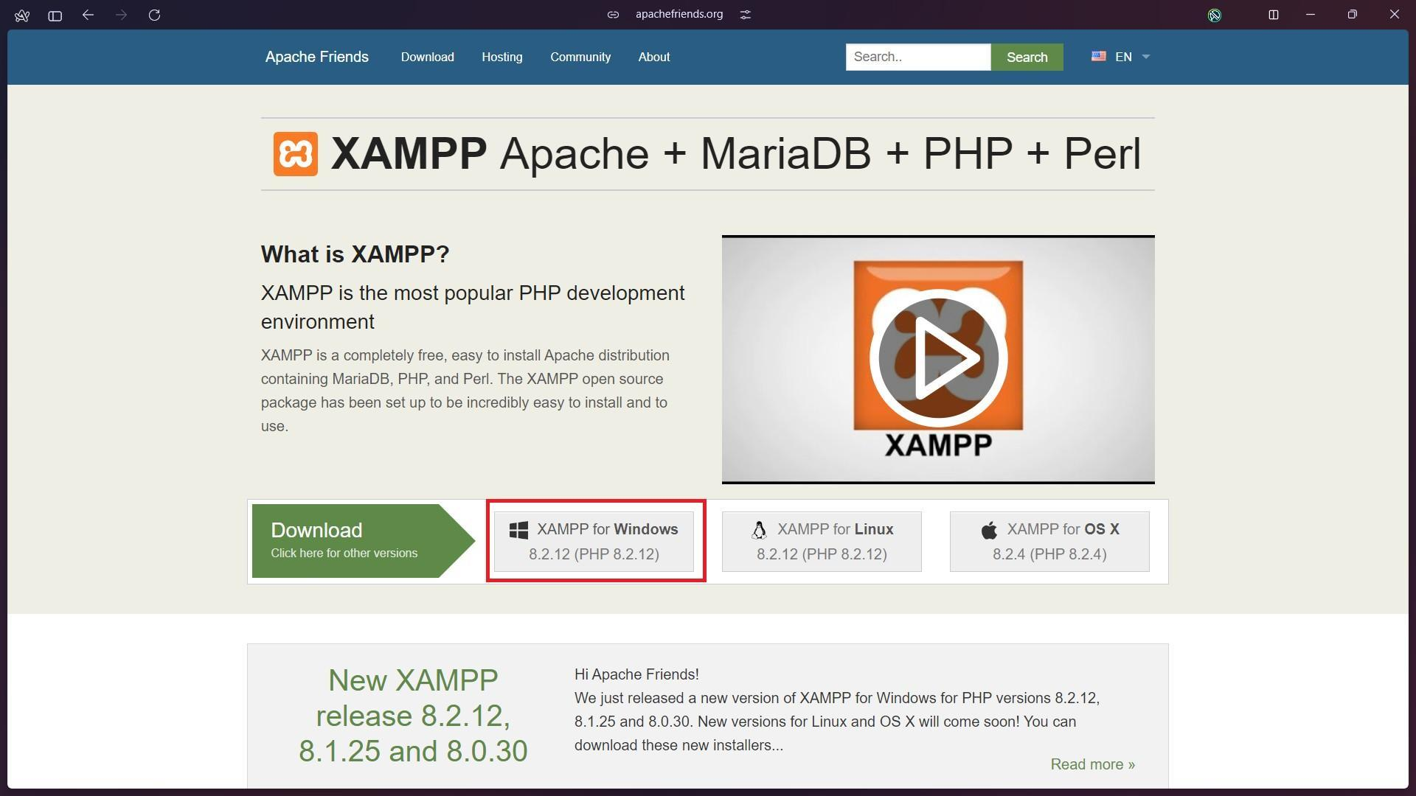
2. Open the setup file. Select all the required components and click next

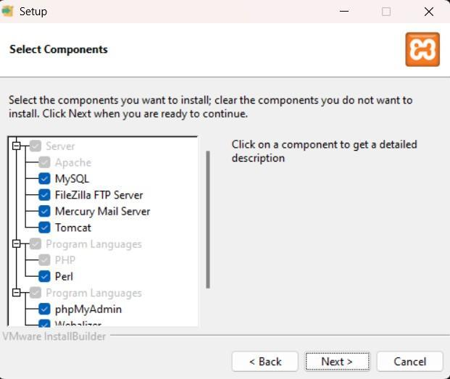

1. Choose the folder to install XAMPP in. Make sure the folder is empty. Click next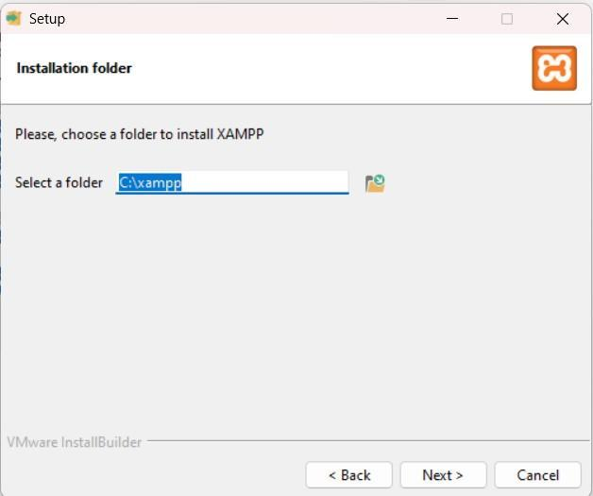
2. Select the language, click next. XAMPP starts to install

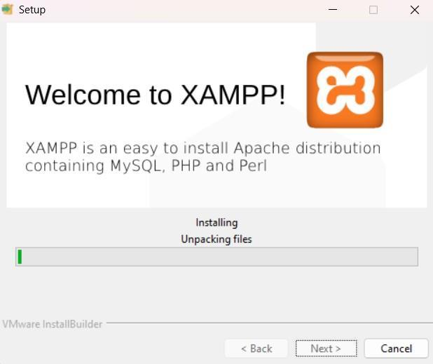

1. The installation is complete. Click Finish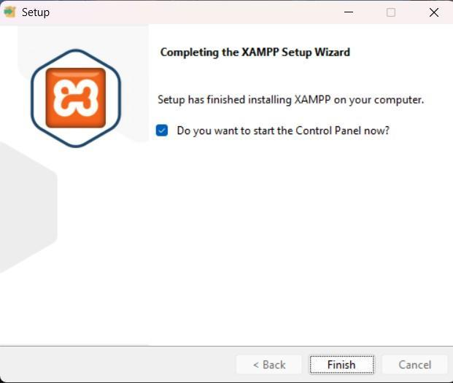

**Step 2:** Setup a file that is to be hosted on the server. Make sure the file has extension **.php**



**Step 3:** Go to the directory where XAMPP was installed. Go to **htdocs** folder. Place your folder in this directory.

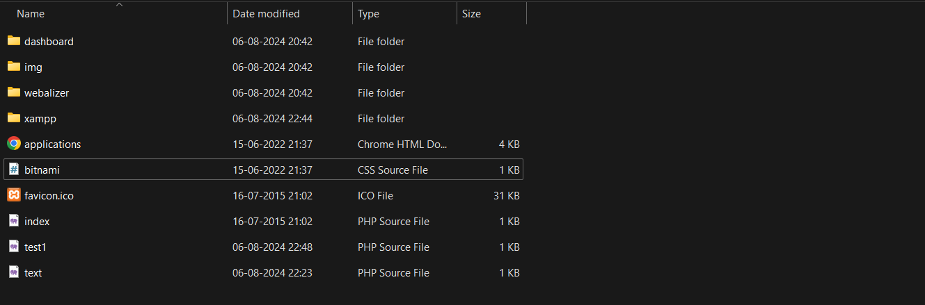

**Step 4:** Open XAMPP Control Panel, start the Apache service (Required) and mySQL service (if needed)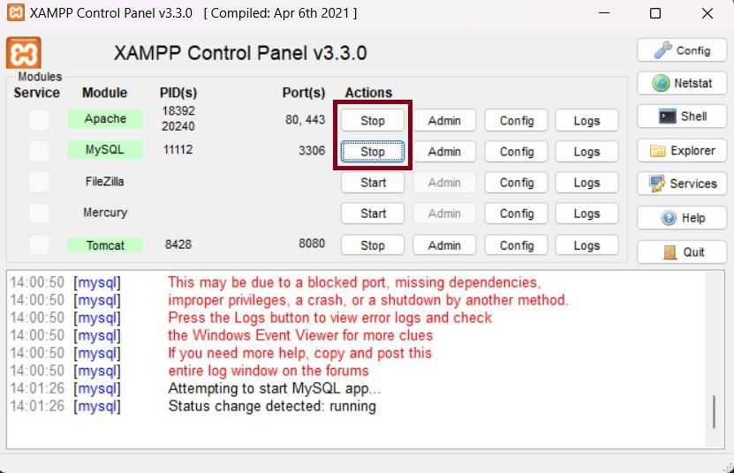

**Step 5:** Open your web browser. Type localhost/YOUR_FILENAME.php. This will open your website on your browser.

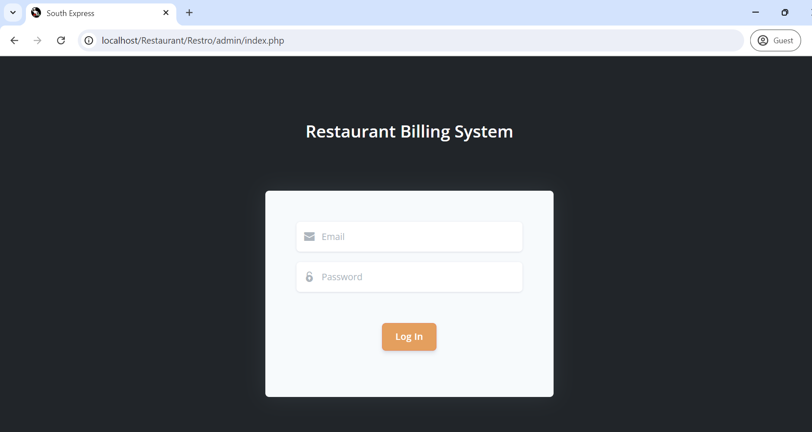

# 2) AWS S3

**Step 1:** Login to your AWS account. Go to services and open **S3.**

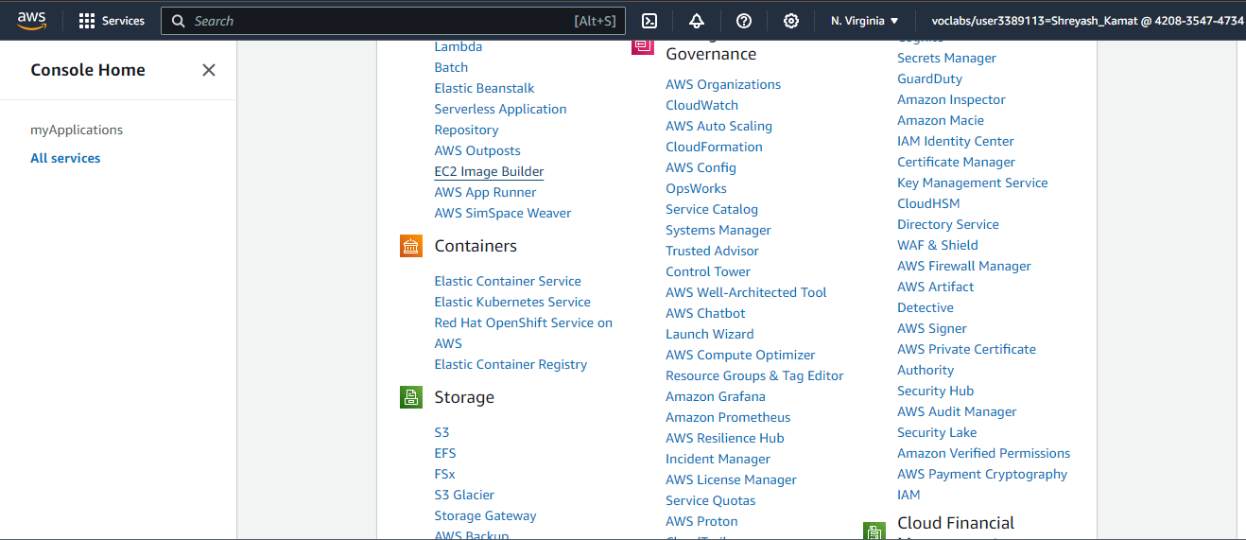

**Step 2:** Click on Create Bucket

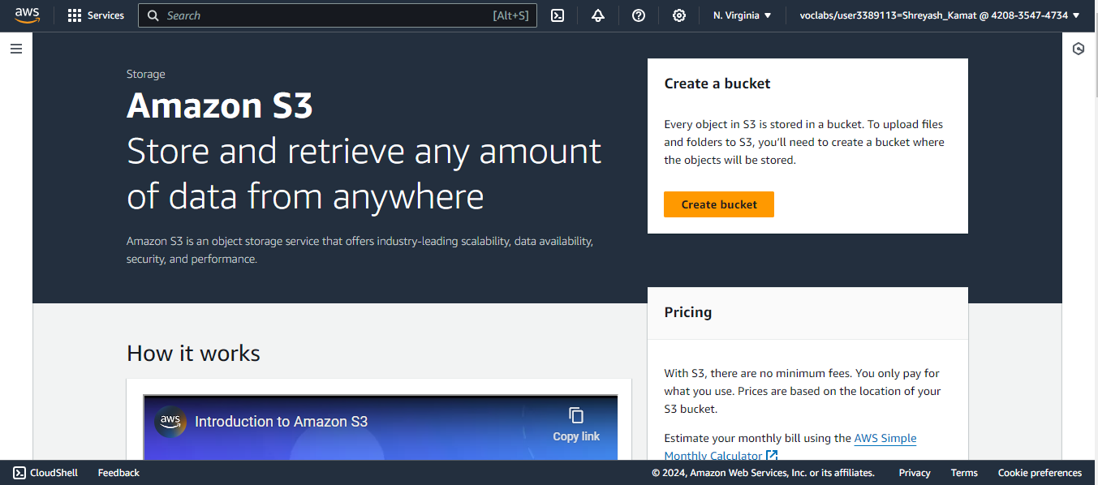

**Step 3:** Give a name to your bucket, keeping other options default, scroll down and click on Create Bucket

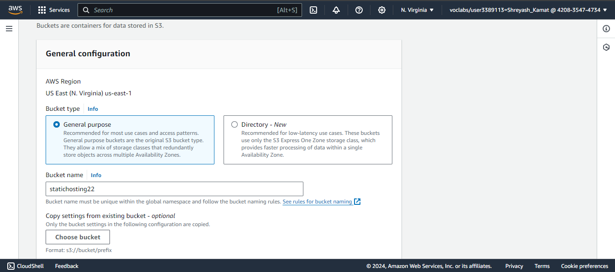

**Step 4:** Click on the name of your bucket and goto Properties

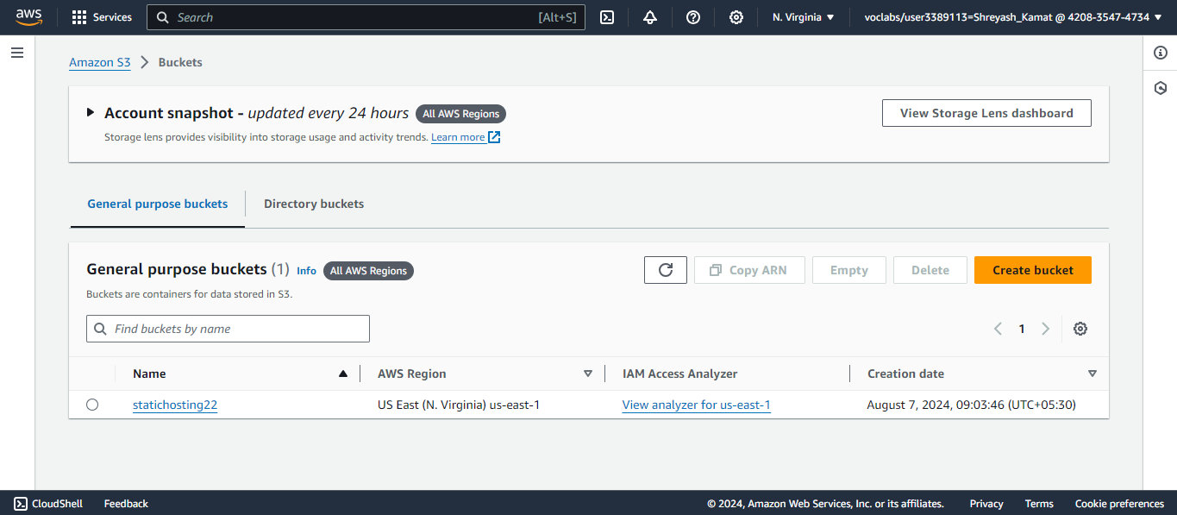

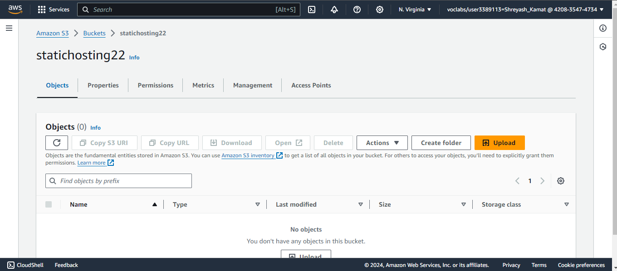

**Step 5:** Scroll down till you find Static website hosting, click on edit

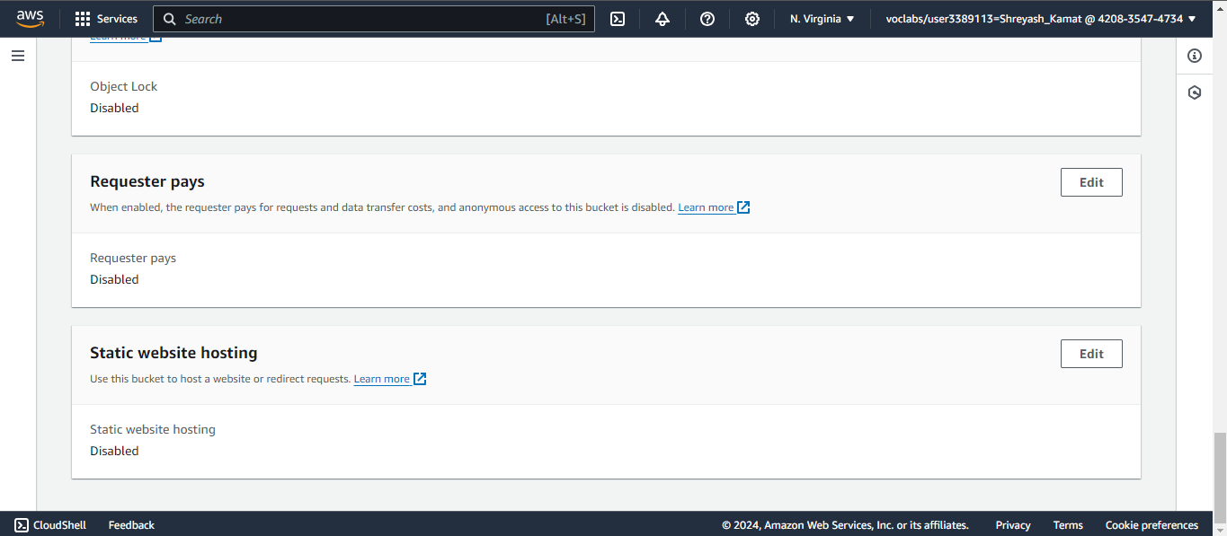

**Step 6:** Enable static website hosting, in Index document, write the name of your document and in error document, give name as 404.html. Save your changes.

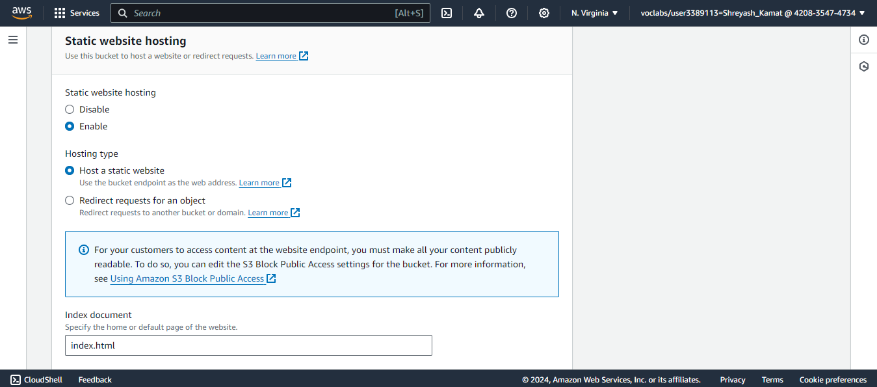

**Step 7:** Go to the Objects tab and click on the upload file.

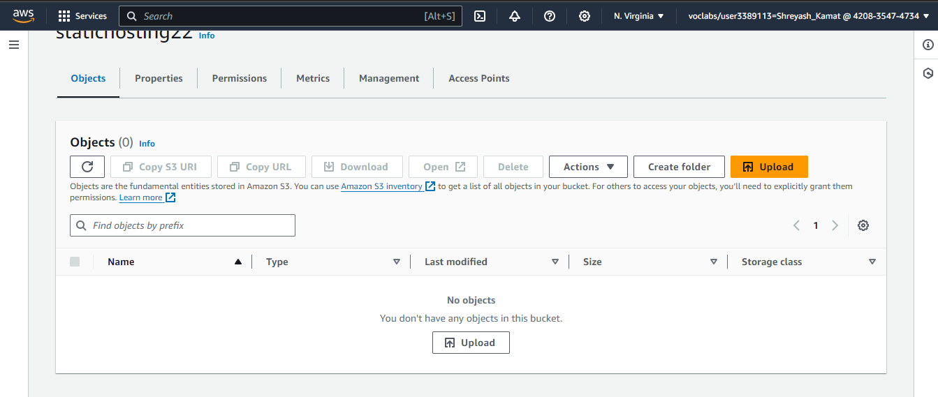

**Step 8:** Click on Add files. Add all the files you want to upload. Then scroll down and click on Upload

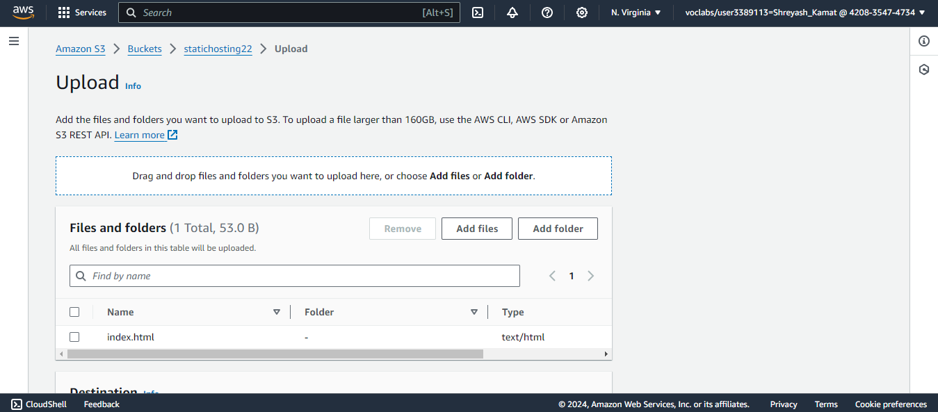

**Step 9:** This will take you to the Objects screen. Switch to Properties, scroll down to Static web hosting. There you would find the link (Bucket website endpoint) to your website.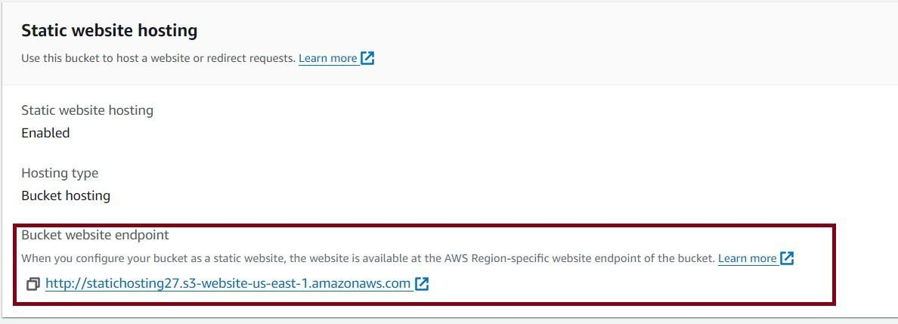

**Step 10:** Open the link. It will show a 403 forbidden error screen as the contents of the bucket are not available for the public users. To change this, go to Permissions tab, go to Block public access and click on edit



**Step 11:** Uncheck the Block all public access checkbox and click on save changes

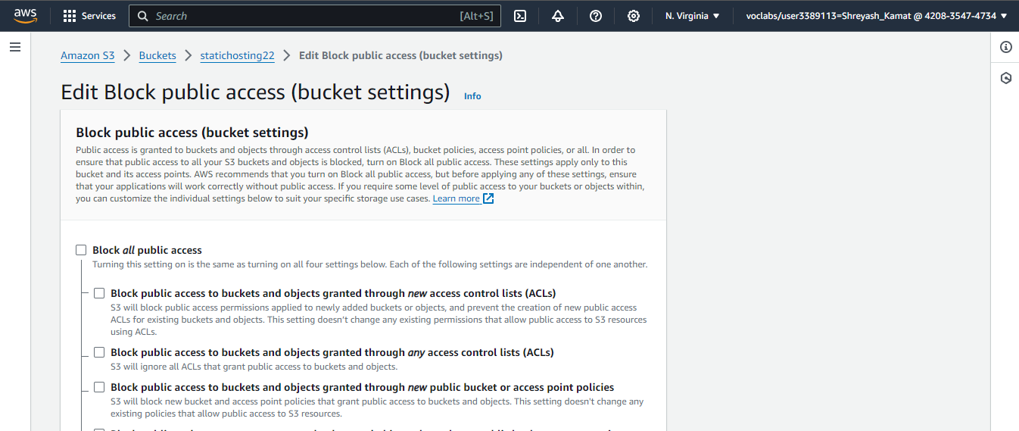

**Step 12:** Scroll down to bucket policy and click edit

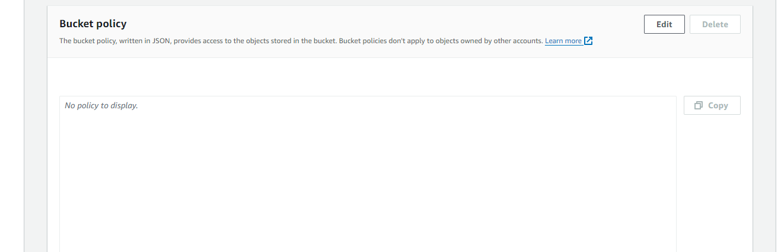

**Step 13:**

{

"Version": "2012-10-17",

"Statement": [

{

"Sid": "PublicReadGetObject", "Effect": "Allow",

"Principal": {

"AWS": "*"

},

"Action": "s3:GetObject",

"Resource": "arn:aws:s3:::YOUR-BUCKET-NAME-HERE/*"

}

]

}

Paste this code snippet in the policy textarea. Replace YOUR-BUCKET-NAME-HERE with the name you have given to your bucket. Save the changes.

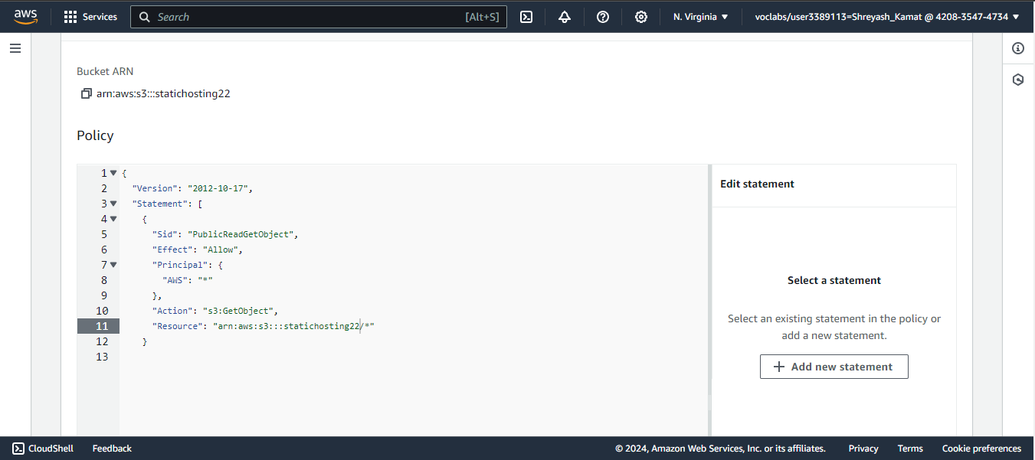

**Step 14:** Now reload the website. You can see your website

